|  |  |
| --- | --- |
| **Project – External Document** |  |
| MOBI6026001  Mobile Cloud Computing |
| Odd Semester Year 2022/2023 |

● **Group Member**

1. 2502000174 – Reynard Octavius Tan
2. 2502032705 – Christine Putri
3. 2501970802 – Jonathan Woen

● **Project Title**

Project Mobile Cloud Computing - HE Fish - Kelompok 9

● **Introduction**

In today’s age, mobile applications are becoming an integral part of our daily lives. From communication to entertainment, these apps make our lives easier. In the field of education, mobile applications have also become a vital part of the industry, making learning more enjoyable and interactive.

Introducing our mobile application “HE Fish”, an interactive and educational tool made to help people know about different types of fish and provide information about fish price. With an easy interface and interesting design, our app makes it easy for users to use and discover more about fish.

The app is divided into different pages, such as “fresh water fish”, “salt water fish”, and “mix water fish”, where users can find information and prices about the fish that are found in the category.

● **Report / Documentation**

**Application Logo :**

Here is our app logo. With the theme of the sea with its typical fish characterizing our application. The fish that seems to jump from the surface of the water illustrates that we want to give maximum results by pushing ourselves beyond our own limits. By continuing to upgrade ourselves and keep learning, one of them is by making this app.

**Application Documentation:**

Sign In / Login Page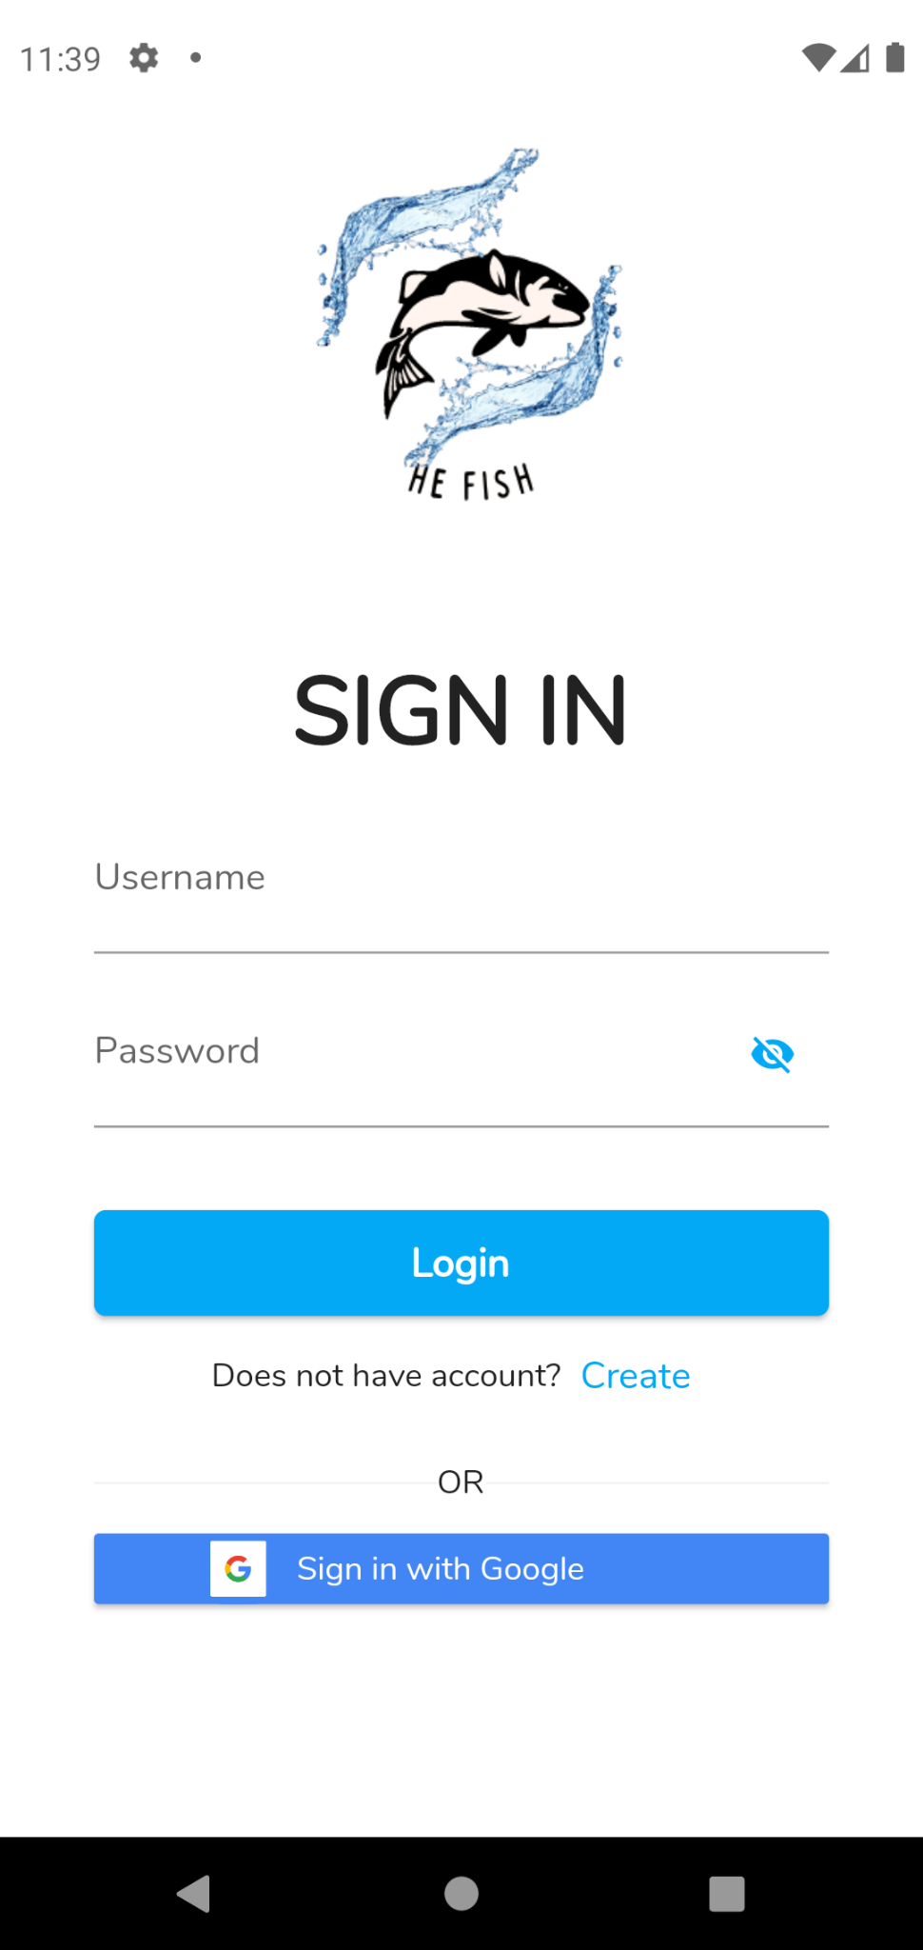

Inside the login page, there are many ornaments; He Fish logo image at the top center to give a beautiful impression to the application. Then below it there is a text field for users to input their username and password to enter the He Fish application. And there is also a login button which when pressed will directly link the user account to log in. Users can also log in using their google account.

Sign Up / Register Page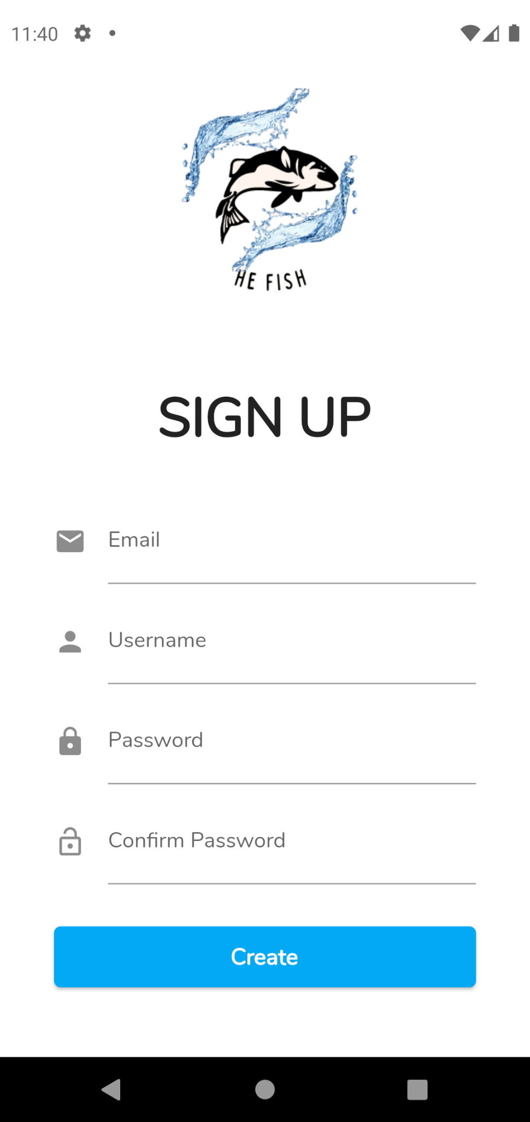

If the user does not have an account in our application, the user can press create on the previous page. Then the user will be directed to the register page. On this page there are many textfields as input from the user; be it username, user email, password, and confirm password on it. There is also a button that can validate whether the user's input is correct or not.

Home Page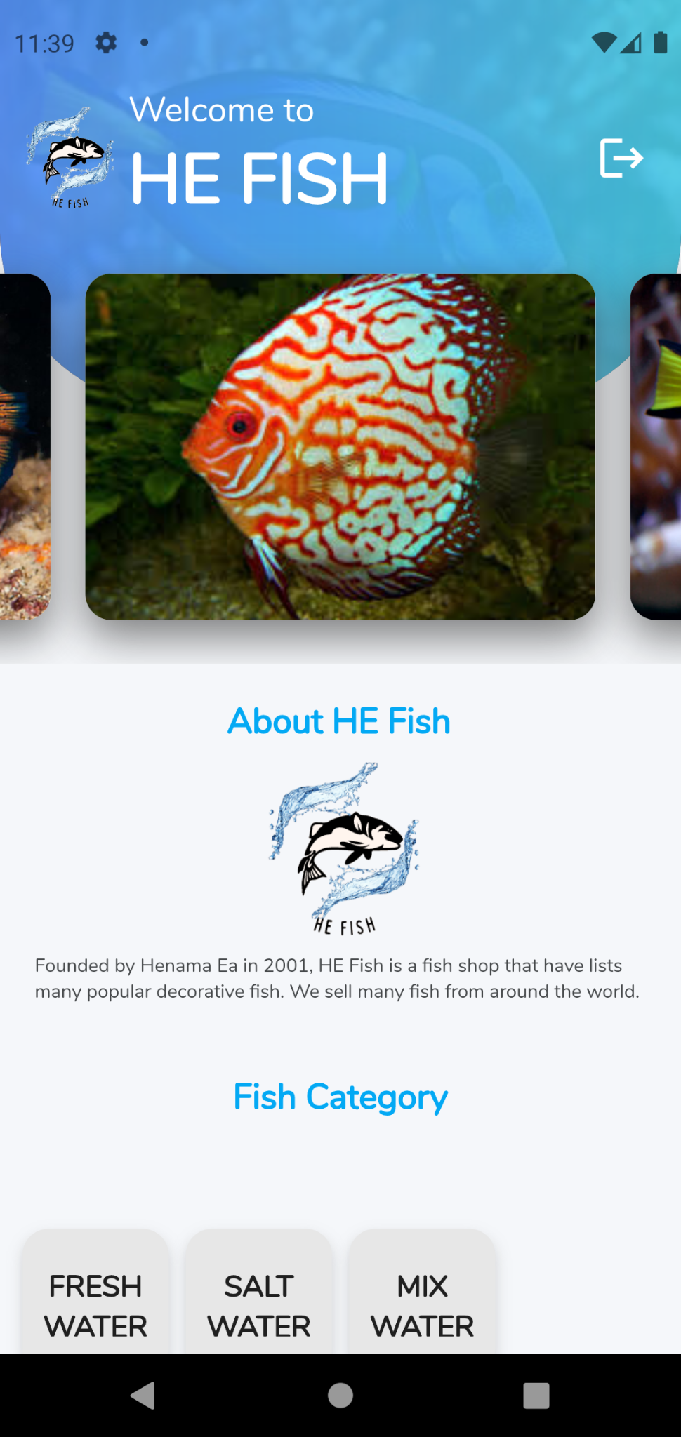

After logging in in the first step. Then the user will be directed to the home page. Here the user will be warmly welcomed, and also decorated with visualizations of beautiful fish in the application. The visualization image can change every three seconds. Also below there is a description of the company that made the application which we named “Henama Ea”. Then at the bottom there is a grid that when pressed will direct to the type of fish shown. Not to forget on the top right side there is a logout button for users if they want to log out of the application.

Fish Page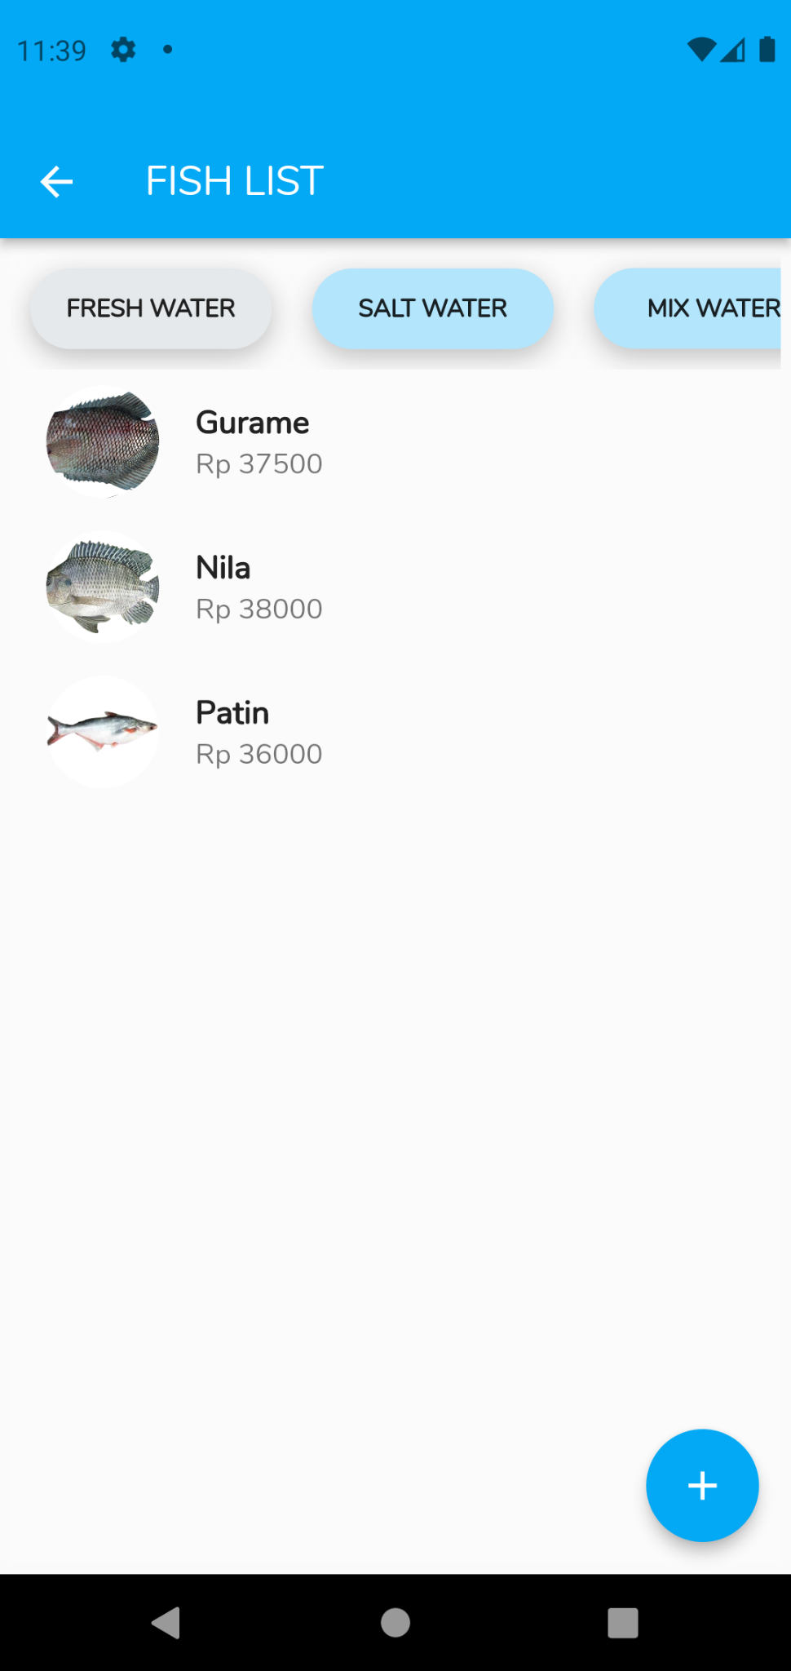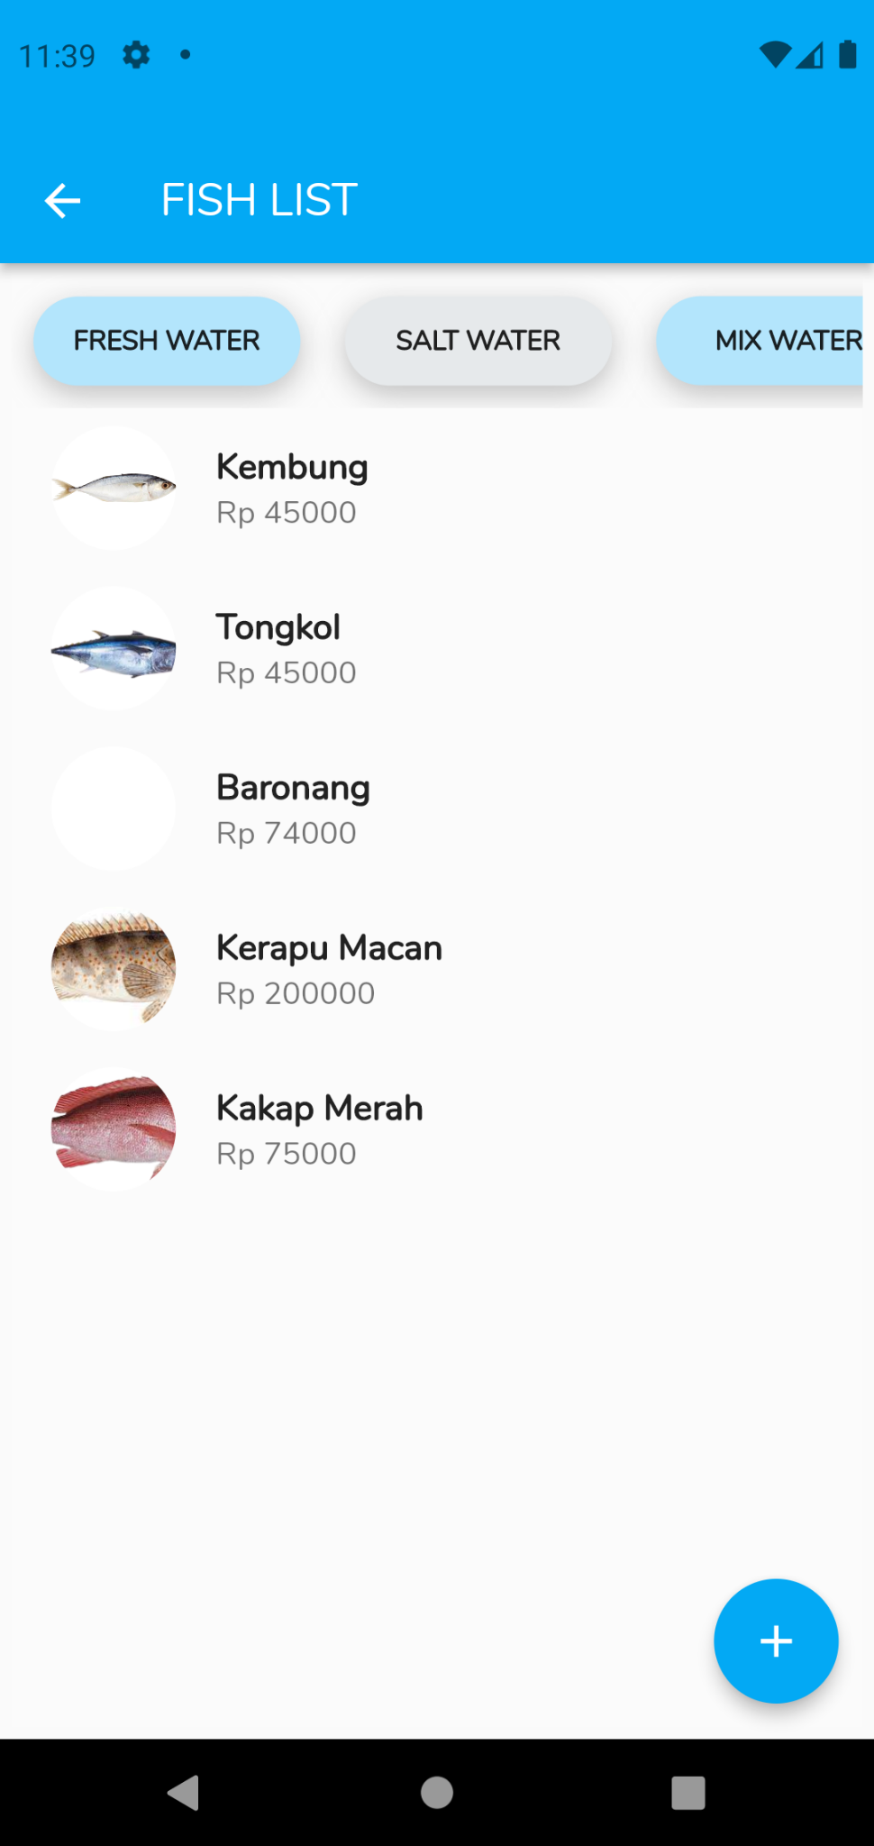

*– This is our fishlist Page –*

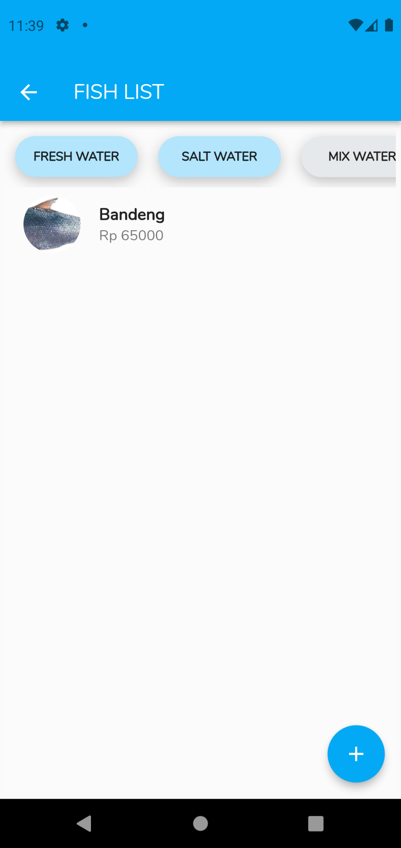

This is the fish list page, it contains a tab view on the top screen, which has the option Fresh Water, Salt Water, and Mix Water. All of the options contain the fish of that category. This page also has a button which when pressed is going to redirect the user to the Insert Fish page.

Detail Fish Page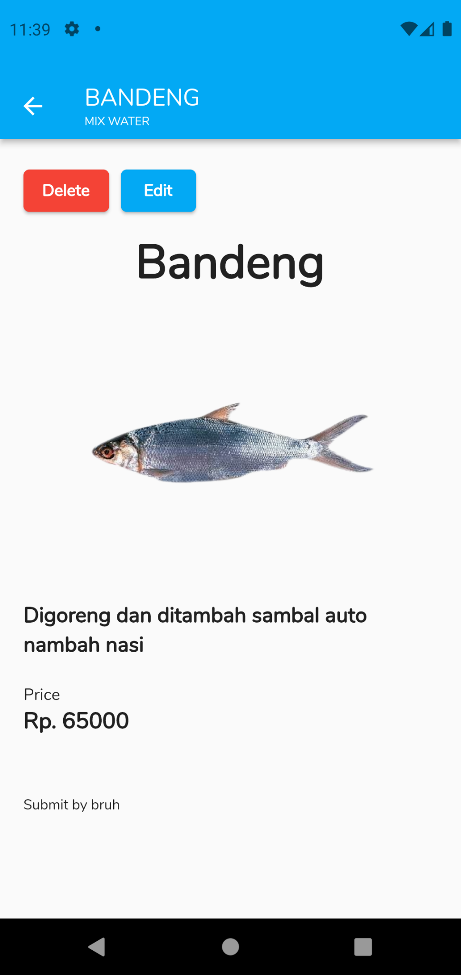

*– This is just an example of our detail fish pages–*

This page is used to know the details of a fish. It contains the fish name, the fish description, the fish price, and who submitted this fish list. This page also has the option to delete or edit the fish list for the admin.

Insert Fish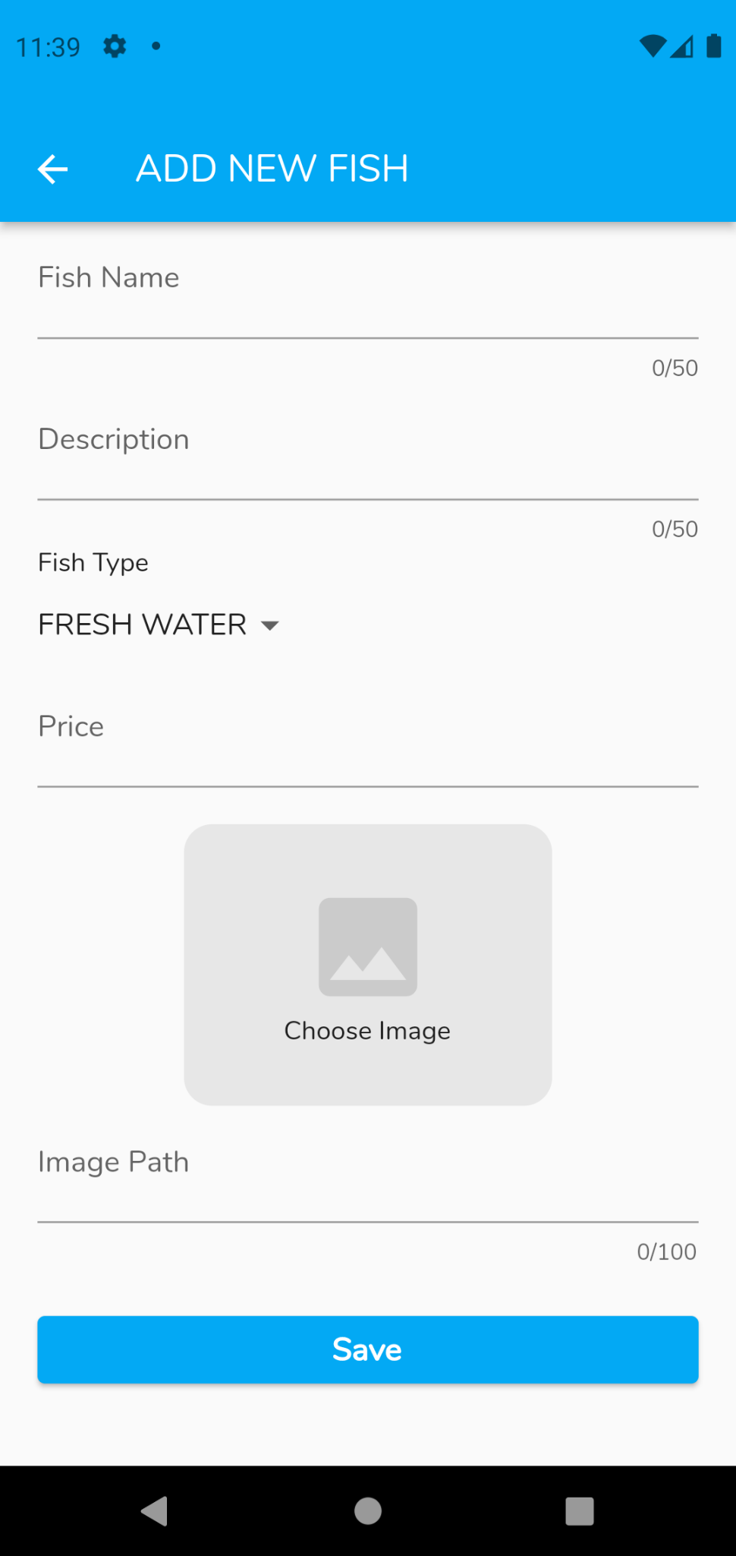

This page is used to insert a new to the fish list. Users can add a fish to the list. The page contains The fish name, the fish description, the fish type which when pressed contains the 3 types of fish, the fish price and the Image that will be used to show the fish, you can also pick the image from ur device and/or your Google Drive.

Update Fish Page 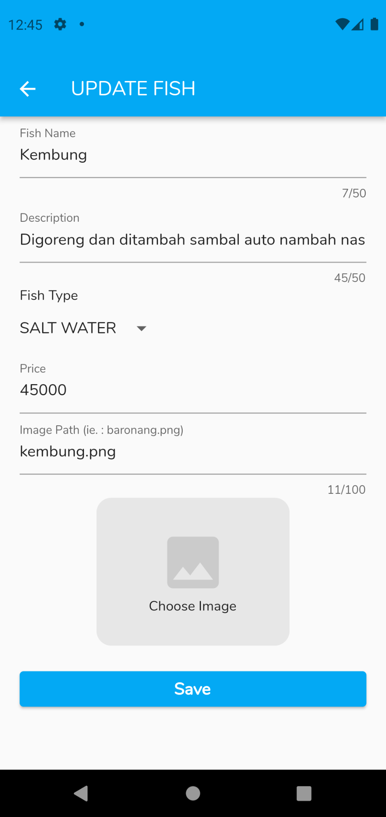

This page is used to update the fish list. Users can edit all the aforementioned descriptions of a fish in the fish list.

**Application Images link / PNG :**

* **For Image in Home Page:**

<https://azure.wgp-cdn.co.uk/app-practicalfishkeeping/features/4c5938a971f72.jpg?&width=1200&height=630&mode=crop&format=webp&webp.quality=40&scale=both>

<https://images.squarespace-cdn.com/content/v1/552b8b01e4b0ee740dee0bf1/1615173099007-VD92CHZHW5BQB94VLTSR/Mandarin+Asli>

<https://images.squarespace-cdn.com/content/v1/552b8b01e4b0ee740dee0bf1/1614162260254-VS9XH1G63YW1RNS3OOZ6/BlueTang_Dory.jpg>

[https://encrypted-tbn0.gstatic.com/images?q=tbn:ANd9GcQaC3b9tbwWwHt20YPcJdFNV3fRABC6yczzLQ&usqp=CA](https://encrypted-tbn0.gstatic.com/images?q=tbn:ANd9GcQaC3b9tbwWwHt20YPcJdFNV3fRABC6yczzLQ&usqp=CAU)

* **For Image in Detail Fish Pages**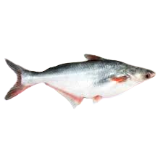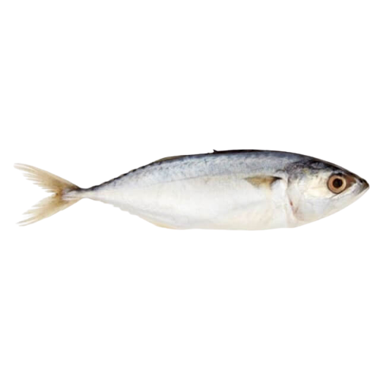

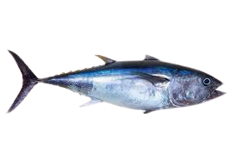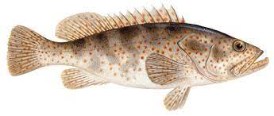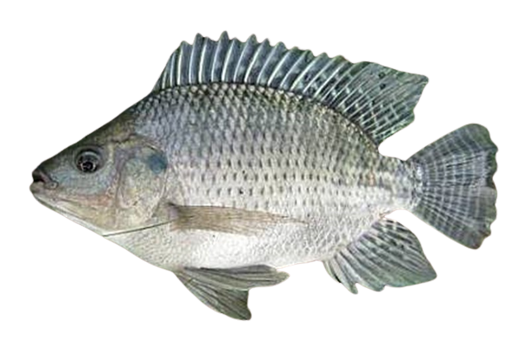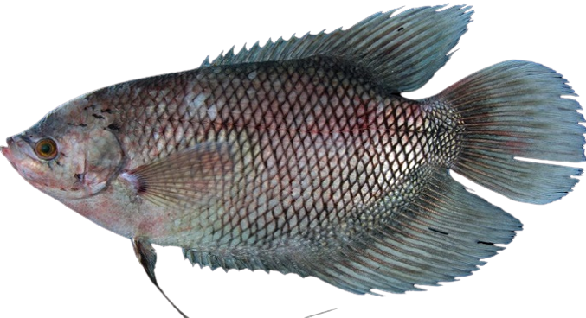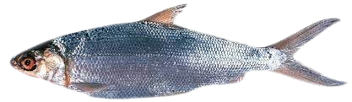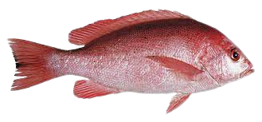

**All Package :**

* flutter/material.dart
* flutter/services.dart
* he_fish/pages/registration.dart
* he_fish/constants.dart
* he_fish/pages/edit_fish.dart
* shared_preferences/shared_preferences.dart
* http/http.dart
* he_fish/pages/front.dart
* loading_overlay/loading_overlay.dart
* shared_preferences/shared_preferences.dart
* image_picker/image_picker.dart
* he_fish/pages/insert_fish.dart
* he_fish/pages/login.dart
* he_fish/pages/fish_category.dart
* carousel_slider/carousel_slider.dart
* he_fish/constants.dart
* he_fish/components/fishtypeslist.dart
* he_fish/model/fishtype_model.dart
* loading_overlay/loading_overlay.dart
* flutter_signin_button/flutter_signin_button.dart
* form_field_validator/form_field_validator.dart
* fluttertoast/fluttertoast.dart
* he_fish/helper/google_signin_api.dart

● **Reference**

**Binus Documentation :**

* + Beginning App Development with Flutter, Chapter 1
  + Beginning App Development with Flutter, Chapter 2
  + Beginning App Development with Flutter, Chapter 3
  + Beginning App Development with Flutter, Chapter 4
  + Beginning App Development with Flutter, Chapter 5
  + Beginning App Development with Flutter, Chapter 6
  + Beginning App Development with Flutter, Chapter 7
  + Beginning App Development with Flutter, Chapter 12
  + <https://www.restapitutorial.com/>
  + <https://reactjs.org/>
  + <https://www.json.org/json-en.html>

**Internet and Media :**

* + Harga.top (2023), “Harga Ikan Gurame”, diterbitkan oleh Harga.top.

<https://www.harga.top/harga-ikan-gurame/>

* + Dinas Kelautan dan Perikanan (2017), “Informasi Harga Ikan Tawar”, diterbitkan oleh Jogja Istimewa.

<https://dislautkan.jogjaprov.go.id/web/hargaikan_tawar>

* + GDM Agri (2021), “Daftar Harga Ikan Patin Lengkap”, diterbitkan oleh GDM Agri.

<https://gdmagri.com/harga-ikan-patin/#:~:text=1%20kg%20ikan%20patin%20bisa,ribu%20sampai%2036%20ribu%20Rupiah>.

* + Harga.top (2023), “Harga Ikan Kembung”, diterbitkan oleh Harga.top.

<https://www.harga.top/harga-ikan-kembung/>

* + Harga.top (2023), “Harga Ikan Tongkol”, diterbitkan oleh Harga.top.

<https://www.harga.top/harga-ikan-tongkol-per-kg/>

* + Indah Sari (2022), “Harga Ikan Baronang”, diterbitkan oleh Suka Ikan.

<https://sukaikan.com/harga-ikan-baronang/>

* + Anang Panca (2022), “Info Terbaru Harga Ikan Kerapu per Kg”, diterbitkan oleh harga.web.id.

<https://harga.web.id/harga-ikan-kerapu-jenis.info>

* + Dinas Kelautan dan Perikanan (2017), “Informasi Harga Ikan Laut”, diterbitkan oleh Jogja Istimewa.

<https://dislautkan.jogjaprov.go.id/web/hargaikan_laut>

* + Dian Kartika (2022), “Update Harga Ikan Bandeng per Kg di Pasaran”, diterbitkan oleh harga.web.id

<https://harga.web.id/harga-ikan-bandeng-per-kg-daftar-2019.info>

* + Flutter Widget Package

<https://api.flutter.dev/flutter/material/material-library.html>

* + Create New Package

<https://dart.dev/guides/libraries/create-library-packages>

* + Flutter Constant

<https://pub.dev/packages/flutter_const>

* + App Master (2022), “API untuk Pemula: Bagaimana cara menggunakan API? Panduan Lengkap”, diterbitkan oleh App Master.

<https://appmaster.io/id/blog/api-untuk-pemula-bagaimana-cara-menggunakan-api-panduan-lengkap>

We use an android emulator or android virtual device to run our project. Our project still has some problems that we are still thinking about how to solve. That's all from the documentation report of our application.

== Thank You==

*Jakarta - 2023 - Kelompok 9 - MCC Project*